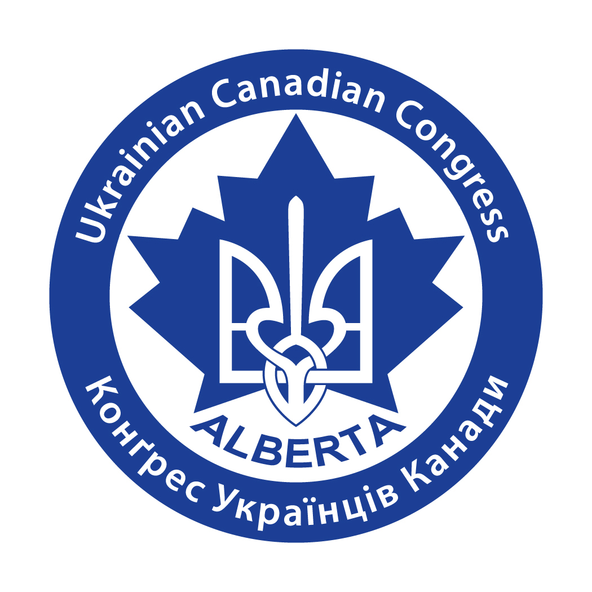
Annual Ukrainian Day Festival
UKRAINIAN CANADIAN CONGRESS
ALBERTA PROVINCIAL COUNCIL
КОНҐРЕС УКРАЇНЦІВ КАНАДИ
ПРОВІНЦІЙНА РАДА АЛЬБЕРТИ

Ukrainian Cultural Heritage Village, Alberta
August 18, 2019
SPONSORSHIP & ADVERTISING OPPORTUNITIES!

On Sunday, August 18, 2019, the UCC-APC, along with several of our member organizations, the Alberta Council for the Ukrainian Arts, the Friends of the Village Society, and the Ukrainian Cultural Heritage Village, will be celebrating our annual Ukrainian Day festival at the Ukrainian Village located east of Edmonton.
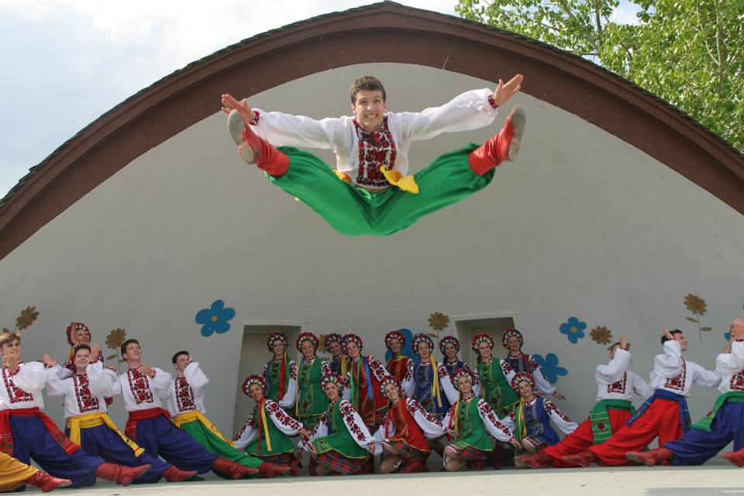
Regardless of where guests roam throughout the large site of the Ukrainian Cultural Heritage Village, there will be something for them to see and do. The festival includes several activities, talent showcases, and commemorative events promoting and celebrating Ukrainian-Albertan heritage and culture. With the help of our feature guest performers Volya Ukrainian Dance group, Dnipro Choir, Steppe Band, Bandurysty from Calgary, and the winner of season 9 The Voice, Oksana Mukha from Lviv, Ukraine; we are proud to mention that this years’ festival will include the celebration of Ukrainian Independence along with celebrating our youth.
Additionally, this year’s event will be the 43nd Ukrainian Day celebration held at the Ukrainian Cultural Heritage Village. Consequently, Ukrainian Day 2019 is expected to be among our organization’s largest and most elaborate celebrations ever.

Ukrainian Day is a unique opportunity to showcase your organization, business or services to a large, diverse audience. A chance to show your community spirit and caring, while at the same time fostering brand recognition throughout the Ukrainian community. All sponsors will be profiled to maximum capacity by UCC-APC.
You can show your support of Alberta’s vibrant Ukrainian community at one of several different levels of sponsorship.
All Ukrainian Day sponsors will be acknowledged. In addition, each level of sponsorship has a wide variety of profile and marketing opportunities.

All sponsors will be provided with:

- Logo and recognition on UCC-APC website, e-Bulletins, program booklet and media releases
- Prominent signage at Ukrainian Day (sponsor to provide banner)
- Announcements and recognition of sponsorship by the Emcee at the Showcase Concert
- Opportunity to distribute corporate marketing item/brochure (must be approved by the UCC-APC)
- Acknowledgement in the UCC-APC newsletter article about Ukrainian Day.

A. 2019 Ukrainian Day
Presenting Sponsor
$5,000

The Presenting Sponsorship is a unique opportunity for a company/organization to attach its name and reputation to an important annual event and be associated with the broader community in Alberta. This is a co-branding opportunity with the potential for lasting recognition and offers the chance for your corporate/organization name and logo to be prominently melded into all 2019 Ukrainian Day advertising and promotion. In addition to the promotional and advertising opportunities previously mentioned, you will also receive:

- Naming opportunity of the event, i.e. UCC-APC and ‘your company’ present Ukrainian Day 2019
- Opportunity to use ‘Ukrainian Day Sponsor’ on your promotional and advertising materials
- Opportunity to develop a special marketing item/component at the Ukrainian Day event
- Link from the UCC-APC website to your organization’s website
- First right of refusal for next year’s presenting sponsorship
- Corporate Logo on an email announcement acknowledging and promoting the sponsorship (5000+)
- Your corporate logo on all our emails promoting the event, broadcast directly to over 5000 contacts (targeted to community leaders, local business, individuals and media)
- Logo on the cover of the Ukrainian Day program book, 3000+ distributed at the event and mailed around Alberta
- Full page ad in the Ukrainian Day program book (3000+ copies)
- Corporate Logo on an e-Bulletin announcement acknowledging and promoting the sponsorship (5000+)
- Half page ad in the UCC-APC newsletter, distributed to 1500+ contacts
- Special VIP luncheon with unique entertainment
B. 2019 Ukrainian Day
Concert Showcase Sponsor
$3,000
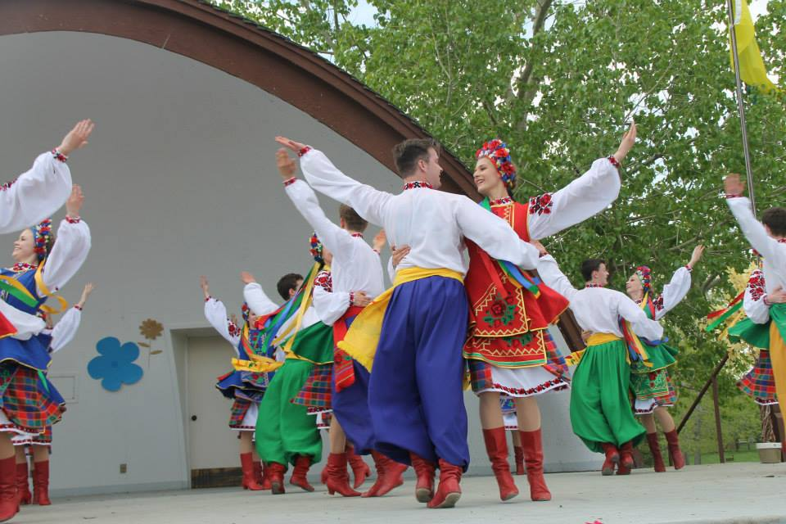
This Sponsor receives many benefits from sponsoring the headline event of the afternoon at Ukrainian Day, the Ukrainian Showcase performance. In addition to the promotional and advertising opportunities previously mentioned, you will also receive:

- Opportunity to use ‘Ukrainian Day Sponsor’ on your promotional and advertising materials
- Link from the UCC-APC website to your organization’s website
- First right of refusal for next year’s concert sponsorship
- Opportunity for corporate/organization name and logo to be displayed on the main stage (banner to be provided by the sponsor)
- Your corporate logo on all our emails promoting the event, broadcast directly to over 5000 contacts (targeted to community leaders, local business, individuals and media)
- Logo on the acknowledgement page in the Ukrainian Day program book (3000+)
- Half page ad in the Ukrainian Day program book (3000+ copies)
- Corporate Logo on an e-Bulletin announcement acknowledging and promoting the sponsorship (5000+)
- Quarter page ad in the UCC-APC newsletter, distributed to 1500+ contacts, and on-line
- Special VIP luncheon with unique entertainment
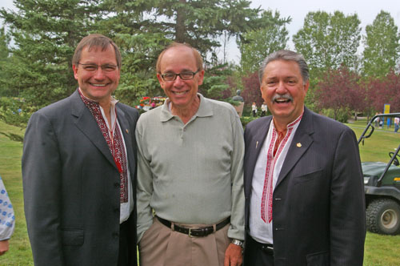

C. 2019 Ukrainian Day
Silver Sponsor
$2,000
This sponsor will receive many benefits and prominent positioning of your organization’s name and logo on all Ukrainian Day promotion and advertising materials. In addition to the opportunities mentioned above, you will also receive:

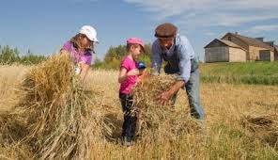
- Opportunity to use ‘Ukrainian Day Sponsor’ on your promotional and advertising materials
- Link from the UCC-APC website to your organization’s website
- Your corporate logo on all our emails promoting the event, broadcast directly to over 5000 contacts (targeted to community leaders, local business, individuals and media)
- Logo on the acknowledgement page in the Ukrainian Day program book 3000+)
- Half page ad in the Ukrainian Day program book (3000+ copies)
- Acknowledgement in the UCC-APC newsletter, distributed to 1500+ contacts, and online

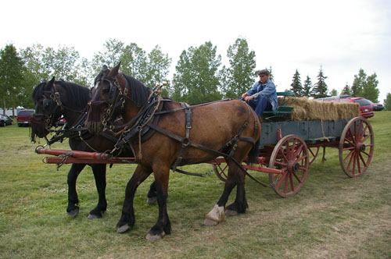

D. 2019 Ukrainian Day
Bronze Sponsor
$750
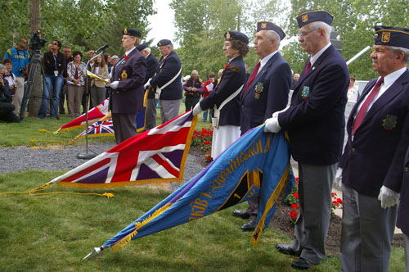
For your sponsorship of this special event, you will receive positioning of your organization as follows:

- Your corporate logo on all our emails promoting the event, broadcast directly to over 5000 contacts (targeted to community leaders, local business, individuals and media)
- Logo on the acknowledgement page in the Ukrainian Day program book (3000+)
- Quarter page ad in the Ukrainian Day program book (3000+ copies)
- Logo and recognition on the UCC-APC website
- Announcements and recognition of sponsorship by the Emcee at the Showcase Concert
- Prominent on site signage
- Acknowledgement in the UCC-APC newsletter article about Ukrainian Day, and on-line

E. 2019 Ukrainian Day
Activity Sponsor
$500

Businesses and organizations also have an opportunity to sponsor a specific component of Ukrainian Day 2018. Activity areas include:

- Stage Sponsor
- Arts and Crafts Sponsor
- Market Sponsor
- Children’s activities and games

For your sponsorship of this special component, you will receive positioning of your organization as follows:

- Quarter page ad in the Ukrainian Day program book (3000+ copies)
- Logo and recognition on the UCC-APC website
- Prominent Signage at the sponsorship area (banner to be provided by the sponsor)
- Recognition on the acknowledgement page of the Ukrainian Day program book
- Acknowledgement in UCC-APC newsletter article about Ukrainian Day, and on-line.

Slavka Shulakewych,
Provincial Coordinator
UCC Alberta Provincial Council
# 8, 8103-127 Ave, Edmonton, AB T5C 1R9
Tel. 780.414.1624
E-mail: uccab@shaw.ca

F. In-Kind Sponsor

To mount any event there are many needs and opportunities for businesses to provide in-kind support for items such as:

- Decorations
- Tents
- Design of Promotional Materials
- Printing of Promotional Materials
- Technical equipment and support

If you are interested in an in-kind sponsorship,
recognition will be provided at the level of support provided - in Program booklet, website, e-Bulletin.
Please contact our office for more details.
The Ukrainian Day Souvenir Program Booklet
Advertising Opportunities!
Printed in full colour!

The Ukrainian Day Booklet is distributed free of cost to all attendees during annual Ukrainian Day festivities.
Advertising rates:
Taxes do not apply to prices!

Full page
7 ¹/₄ “ x 9 ¹/₄ ” = $800

Half page
3 ¹/₂ “ x 9 ¹/₄ ” or 7 ¹/₄ ” x 4 ¹/₂ ” = $ 535

Quarter page
3 ¹/₂ “ x 4 ¹/₂ ” = $325

Business card
3 ¹/₂ “ x 2 “ = $190

DEADLINES:
Ad space reservation - June 14, 2019
Ad material submission – June 28, 2019

* Orders received after the deadline will only be accepted based on space availability

